
Electronics Retail Sales Analysis Using Power BI



Name: Rakshana U B.Com (FinTech & AI)
E25FA036

1. Introduction
The Electronics Retail Sales Analysis project focuses on analysing sales data using Microsoft Power BI. The main purpose of this project is to understand the sales performance of an electronics retail business through data cleaning, data modelling, calculations and visualisation.
In this project, nine CSV files were imported into Power BI. The data was cleaned and organised using Power Query Editor. Relationships were created between different tables to establish a proper data model.
DAX measures were created to calculate important business information such as total revenue, total profit, total cost, total quantity and average order value.
Finally, an interactive Retail Sales Dashboard was developed using different charts, cards, tables and slicers. This dashboard helps users understand sales performance across product categories, stores, cities, customers and different time periods.
3. Objectives of the Project
The main objectives of this project are:
- To import and organise sales data from nine CSV files.
- To clean the data and correct the data types.
- To create relationships between different tables.
- To develop DAX measures for important sales calculations.
- To validate the calculations using filters and slicers.
- To create an interactive sales dashboard.
- To analyse revenue, profit and store performance.
- To understand the practical applications of Power BI in business analysis.
4. Software and Tools Used
- Microsoft Power BI Desktop
- Power Query Editor
- DAX (Data Analysis Expressions)
- CSV files
- Data View
- Model View
- Report View
5. Project Implementation – Step-by-Step Process
Step 1: Importing the Data
Nine CSV files were imported into Power BI Desktop. The project was saved as Electronics Retail Sales.pbix.
The imported files included Fact Sales and different dimension tables containing product, customer, store, city, state, salesperson, date and order information.
Step 2: Data Inspection and Data Cleaning
All the imported tables were inspected using Data View and Model View.
Power Query Editor was used to clean and organise the data.
The following activities were performed:
- Renamed tables with proper capitalisation.
- Changed numerical columns to Whole Number or Decimal Number.
- Changed date columns to Date or Date/Time.
- Converted text-based True/False values into Boolean values.
- Checked the columns for errors.
- Used Change Locale to correctly convert date values.
This step helped to prepare the data for accurate analysis.
Step 3: Creating Relationships
After cleaning the data, eight relationships were created between the Fact Sales table and the dimension tables.
The relationships connected sales records with product, customer, store, salesperson, date and order information. Additional relationships connected city with state and store with city.
All eight relationships were configured with:
- Many-to-one (*:1) cardinality.
- Single cross-filter direction.
- Active relationship status.
This created a connected data model for analysis.
Step 4: Creating DAX Measures
DAX measures were created to calculate important sales performance indicators.
The eight measures included:
- Total Quantity
- Total Revenue
- Total Cost
- Total Profit
- Average Unit Price
- Total Transactions
- Total Orders
- Average Order Value
These measures helped to calculate the overall business performance.
Step 5: Validating DAX Measures
A table visual was created to display all eight measures.
The calculations were checked to ensure that:
- All measures displayed values.
- No calculation errors appeared.
- Currency and number formats were correct.
- The measures responded correctly to filters.
Different slicers were used to test category, store, customer segment, salesperson, year, month, state and city filters.
Step 6: Creating the Retail Sales Dashboard
A new report page named Retail Sales Dashboard was created.
The following visualisations were added:
- Card visuals – Total Revenue, Total Profit, Total Orders and Total Quantity.
- Clustered Column Chart – Revenue by Product Category.
- Treemap – Profit by Product Category.
- Clustered Bar Chart – Revenue by Store.
- Line Chart – Monthly Revenue Trend.
- Doughnut Chart – Revenue Distribution by Store Type.
- Clustered Bar Chart – Revenue by City.
These visualisations helped to present sales information in an understandable graphical format.
Step 7: Adding Slicers and Filters
Five interactive slicers were added to the dashboard:
- Product Category
- Year
- Customer Segment
- Store Type
- State
These slicers allowed users to select different categories and view the corresponding sales information.
Visual-level, page-level and report-level filters were also tested to understand how filters affect dashboard results.
Step 8: Adding Drill-Down Features
Two drill-down features were created.
Category to Subcategory Drill-Down
The Revenue by Product Category chart was modified to allow users to explore revenue from the main product category to individual subcategories.
Year to Month Drill-Down
The Monthly Revenue Trend chart was configured to display revenue by year and then by month.
These features allowed users to explore sales information in greater detail.
Step 9: Creating the Store Performance Table
A Store Performance table was created using:
- Store Name
- Total Revenue
- Total Profit
The table was sorted by revenue in descending order.
Conditional formatting using data bars was applied to make revenue comparisons easier. Revenue sparklines were also added to display trends over time.
Step 10: Creating a Custom Tooltip Page
A separate report page named Store Type Tooltip was created.
The page was configured as a tooltip and included four KPI cards:
- Total Revenue
- Total Profit
- Total Orders
- Average Order Value
The tooltip was connected to the Revenue Distribution by Store Type doughnut chart.
This allowed users to view additional information when interacting with the chart.
Step 11: Editing Visual Interactions
Visual interactions were configured to control how dashboard elements respond to user selections.
Three interaction options were studied:
- Filter
- Highlight
- None
The interactions between the product category chart, store performance table and revenue by store chart were tested.
Step 12: Final Dashboard Testing
The completed dashboard was tested to ensure that:
- All five slicers worked correctly.
- Category and year drill-down features worked.
- Store performance data bars and sparklines were visible.
- The custom tooltip displayed the correct information.
- Multiple slicers worked together.
- All selections were cleared before saving.
The completed Power BI file was saved as Electronics Retail Sales.pbix.
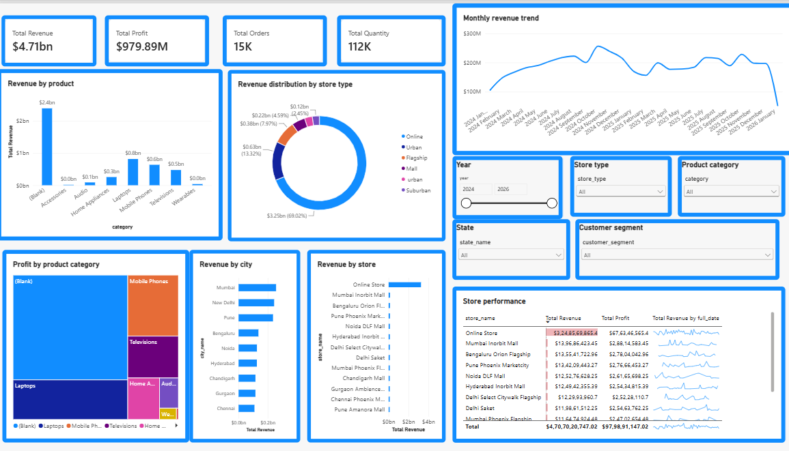
6. Dashboard Analysis and Observations
The Retail Sales Dashboard provides an overview of the electronics retail business.
The dashboard helps to analyse:
- Total revenue and profit generated by the business.
- Sales performance across different product categories.
- Revenue contribution from different stores.
- Monthly revenue trends.
- Revenue distribution by store type.
- Revenue performance across different cities.
- Store-wise revenue and profit comparisons.
The slicers and drill-down options make it easier to explore the data according to different business requirements.
Note: Actual findings, highest-performing categories, stores and numerical results should be added after examining the completed dashboard.
7. Learning Outcomes
Through this project, I gained practical knowledge of Microsoft Power BI and its applications in business analysis.
I learned how to:
- Import and clean multiple CSV files.
- Organise data using Power Query Editor.
- Create relationships between tables.
- Write basic DAX measures.
- Validate calculations using slicers.
- Create different types of charts and visualisations.
- Use filters, drill-downs and tooltips.
- Design an interactive business dashboard.
- Understand sales performance through data visualisation.
8. Conclusion
The Electronics Retail Sales Analysis project provided practical experience in using Microsoft Power BI for business data analysis. Through this project, I learned how to import, clean and organise data, establish relationships between tables and create DAX measures for calculating important sales information.
The interactive dashboard helped me understand how sales performance can be analysed through different visualisations, filters, slicers and drill-down features.
Overall, this project improved my knowledge of data analytics and business intelligence. It also helped me understand how Power BI can support business decision-making by converting raw data into meaningful information.

